Dressage demonstration and picnic at the stables (mid 1980’s)

“Born in Paris in 1929, Jean-Claude Racinet is a graduate of St. Cyr, the French West Point, Class of 1950. He was a member of the French contingent in Korea (1950-53), where he was wounded twice. As an officer of the French army, he spent seven years in Tunisia and Algeria (1954-61) and four more in Europe.
While he spent most of his army career during the time when the military was getting rid of their horses, he managed, between and during his sojourns overseas, to successfully attend the Superior Equitation Course in the Cavalry School of Saumur (1953-54), winning the title of Champion of Tunisia in open jumping (1956), and to become a member of the Jumping Team of the Military School in Paris (1953).
Riding teacher and trainer as a civilian after 1965, he was more particularly known by his retraining of difficult horses and later as an equestrian journalist by his always witty and sometimes scathing articles in the French equestrian monthly L'Information Hippique.
In the United States since 1983, Jean-Claude Racinet became a successful teacher, trainer, lecturer, clinician, and author. Xenophon Press published in 1994 his highly popular book Another Horsemanship, now in its second printing.
Jean-Claude Racinet has devoted his life to the vindication of "L’equitation de Legerete" (riding in lightness), which fosters balance by relaxing the horse - more so his mouth - excluding force in the wielding of the aids. In fact, the very essence of riding in the French Classical tradition.ore years in Europe.
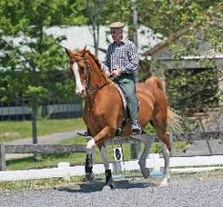

“Jean-Claude was passionate about horses and riding. 'Riding in Lightness' was his brand, mantra, trademark if you will. This was his life blood that would keep him from soundly sleeping at night he would tell me. He was a genius both on and off horse back. Want to know about history or politics, he would clue you in, the NY Times crossword puzzle was his specialty, manipulation of the horse's spine to relieve subluxations, Jean-Claude through thousands of hours of studying and conversations with a prominent French vet-osteopath, had it figured out. “
Excellent introduction to the philosophy, method, and procedures of Francois Baucher, or the French tradition of "riding in lightness" that Baucher developed in the 19th century. Includes a translation of Baucher's "second manner." Jean-Claude Racinet wrote a few articles in the magazine Dressage and CT in 1992-3 on Baucher and his equitation.
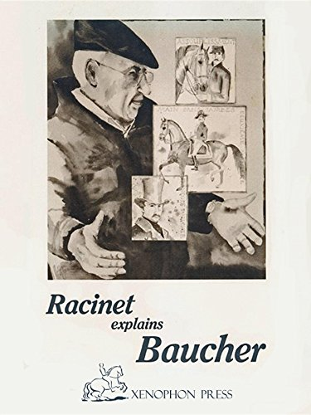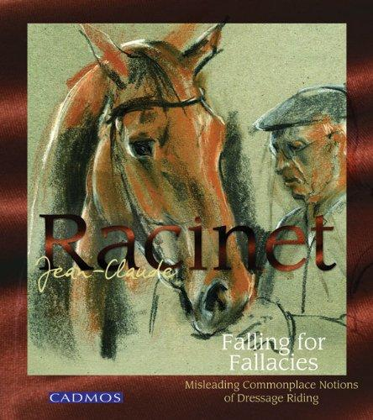
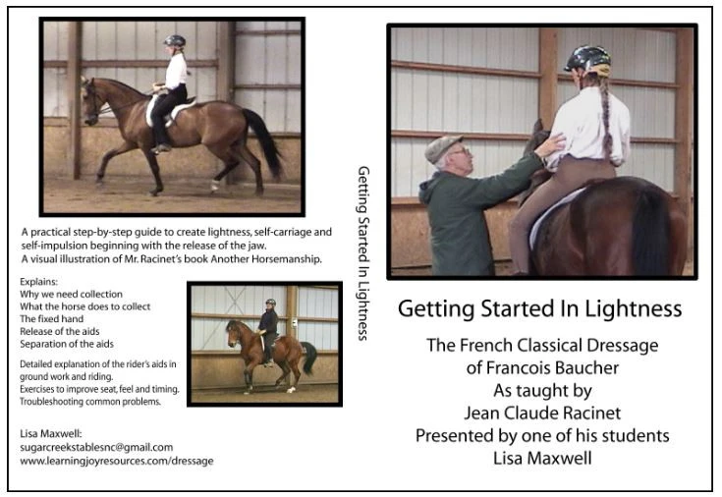

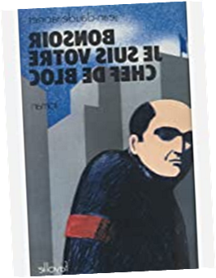
L’homme au couteau entre les dents, tend — en France — à disparaître de la mythologie politique. La dictature ne se porte plus et tous les régimes en « isme » arborent un visage humain. La Gauche bien-sûr, mais aussi l’extrême-Gauche : Georges Marchais, Paul Laurent, Jean Ellenstein, les gauchistes — et tous les autres — envoient le stalinisme dans l’enfer de l’histoire. Le philosophe nouveau est arrivé. Il condamne l’État-flic, les commissaires, les petits chefs, les chefs de bloc, que personne d’ailleurs ne défend plus. Jean-Claude Racinet n’est pas entièrement rassuré par cette chasse au scalp autour d’un goulag mort. Il redoute le retour de vieux démons, et imagine la prise de pouvoir en France par une organisation que ne renieraient pas les États les plus totalitaires. À la suite d’un concours étrange de circonstances, une paisible famille française se trouve face à face avec l’État tout puissant. Tous les lecteurs, de Gauche ou de Droite, en refermant ce livre, resteront rêveurs.

